Field Service & Customer Engagement Platform - Comprehensive Specification
marcdown
# Table of Contents
1. [Introduction](#1-introduction)
2. [Product Vision & Goals](#2-product-vision--goals)
3. [User Roles & Personas](#3-user-roles--personas)
4. [User Experience (UX) & Design](#4-user-experience-ux--design)
5. [AI & Automation Features](#5-ai--automation-features)
6. [Data Model](#6-data-model)
7. [Workflows](#7-workflows)
8. [Technology Architecture](#8-technology-architecture)
9. [Security, Privacy, Compliance](#9-security-privacy-compliance)
10. [Finance Engine](#10-finance-engine)
11. [KPIs & Dashboards](#11-kpis--dashboards)
12. [Acceptance Criteria & DoD](#12-acceptance-criteria--dod)
13. [Delivery Plan](#13-delivery-plan)
14. [Assumptions, Risks & Open Questions](#14-assumptions-risks--open-questions)
1) Introduction
A comprehensive field service platform connecting businesses with certified partners for professional services. The platform manages the entire lifecycle from customer engagement to partner payout, with AI-powered insights and UAE-specific compliance.
Key Differentiators:
- AI-driven assignment and quality assurance
- Multi-currency financial engine with UAE compliance
- Bi-lingual (EN/AR) customer experience
- Real-time field evidence validation

2) Product Vision & Goals
Vision: Become the leading field service platform in UAE by delivering exceptional service quality through certified partners and data-driven insights.
Business Goals:
- Reduce service delivery time by 30% within 6 months
- Achieve 95% first-time-right service quality
- Maintain <2% refund rate through quality controls
- Enable 40% platform commission with transparent partner economics
3) User Roles & Personas
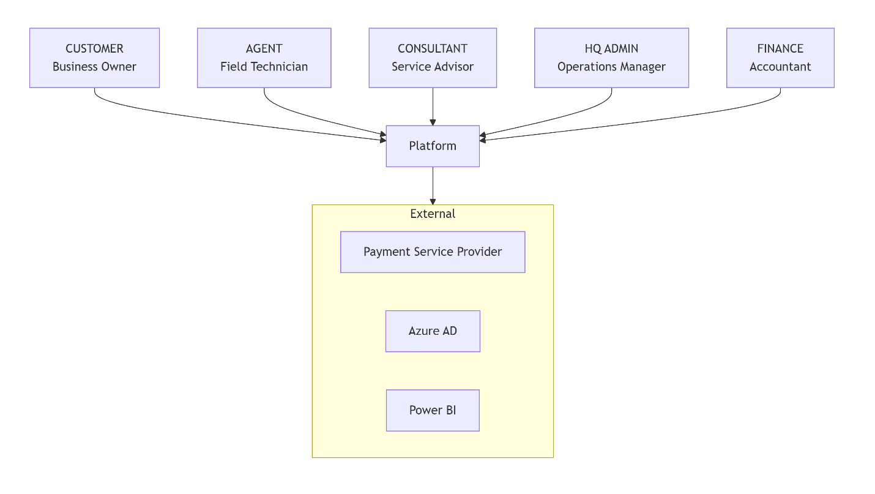
Detailed Personas:
Customer - Ahmed Al Mansouri (Dubai Business Owner)
- Goals: Track service progress, understand costs, ensure quality
- Pain Points: Lack of visibility, communication gaps, inconsistent quality
- Tech Level: Medium - comfortable with mobile apps
- Language: Arabic primary, English proficient
Agent - Maria Santos (Certified Technician)
- Goals: Clear instructions, fair compensation, efficient scheduling
- Pain Points: Unclear requirements, payment delays, poor communication
- Tech Level: High - expert with mobile field apps
- Language: English primary, learning Arabic
Consultant - David Chen (Service Consultant)
- Goals: Close deals quickly, accurate pricing, happy customers
- Pain Points: Manual proposal work, pricing uncertainty, scope changes
- Tech Level: High - advanced business software user
4) User Experience (UX) & Design
Design System Foundation
- Colors: Primary Blue (#0D6EFD), Success Green (#198754), Warning Orange (#FD7E14)
- Typography: Segoe UI (English), Noto Sans Arabic (Arabic)
- Layout: RTL support for Arabic, responsive grid system
- Icons: Material Design Icons with cultural adaptations
Key Screen Specifications
Customer Dashboard (Web/Mobile)
text
┌─────────────────────────────────────────┐
│ Header: Logo, Lang Switch, Notifications│
├─────────────────────────────────────────┤
│ Quick Stats: │
│ ○ Active Engagements: 3 │
│ ○ Upcoming Sessions: 1 │
│ ○ Pending Payments: AED 2,450 │
├─────────────────────────────────────────┤
│ Current Engagement: Office Setup (Day 2) │
│ ┌─ Milestone Progress ──────────────────┐ │
│ │ Planning ████████░░ 80% │ │
│ │ Installation ████░░░░░░ 40% │ │
│ │ Testing █░░░░░░░░░ 10% │ │
│ └───────────────────────────────────────┘ │
│ What's Next: Site survey scheduled today │
│ Chat: "Your agent Maria will arrive at 2PM"│
└─────────────────────────────────────────┘
Agent Task Interface (Mobile-First)
text
┌─────────────────────────────────────────┐
│ Job #SF-2024-0012 - Office Network Setup │
│ Client: TechCorp Dubai │
│ Due: Today 4:00 PM Priority: High │
├─────────────────────────────────────────┤
│ CHECKLIST (3/8 completed) │
│ ☑ Verify site accessibility │
│ ☑ Document existing infrastructure │
│ ☑ Plan cable routes │
│ ☐ Install network switches │
│ ☐ Configure firewall │
│ ☐ Test connectivity │
│ ☐ Client demonstration │
│ ☐ Collect acceptance │
├─────────────────────────────────────────┤
│ EVIDENCE REQUIRED: │
│ • 3+ photos of installation │
│ • Network test results │
│ • Client signature │
│ │
│ [START TASK] [REQUEST HELP] │
└─────────────────────────────────────────┘
Validation Rules:
- Photo evidence: Minimum 3 photos, geotagged within 100m of site
- Time tracking: Automatic clock-in/out with location verification
- Offline support: Queue submissions when connectivity lost
- Bi-lingual validation messages with clear error resolution
5) AI & Automation Features
Model Architecture
Chat Assistants:
python
# Customer Assistant (Arabic/English)
class CustomerAssistant:
model: "GPT-4 Turbo" # Multi-lingual optimized
context: "Engagement context, plan details, agent info"
capabilities: ["progress updates", "next steps", "billing queries"]

prompt_template = """
You are a helpful customer service assistant for our field service platform.
Customer is asking: {query}
Current engagement status: {status}
Next milestone: {next_milestone}

Respond in the same language as the query. Be concise and helpful.
"""

# Deal Desk Assistant
class DealDeskAssistant:
model: "GPT-4 + Custom pricing rules"
context: "Customer history, service catalog, partner rates"
capabilities: ["dynamic pricing", "proposal generation", "discount approval"]
Forecasting Engine:
python
class ForecastingEngine:
# Classical ML for baseline
baseline_model: "Prophet + ARIMA"
# LLM enhancement for anomaly explanation
explanation_model: "Claude-3 for trend analysis"

features: [
"historical_seasonality",
"custom_curve_adjustments",
"market_events",
"partner_availability",
"currency_fluctuations"
]

def detect_anomaly(self, actual, forecast):
return {
"is_anomaly": abs(actual - forecast) > 2 * std_dev,
"confidence": 0.92,
"explanation": "Higher than expected material costs due to supply chain issues"
}
Data Requirements & Feature Engineering
Training Data:
- 12+ months historical service data
- Multi-currency transaction records
- Partner performance metrics
- Customer satisfaction scores
Feature Engineering:
python
def engineer_features(raw_data):
return {
"temporal_features": {
"day_of_week": one_hot_encode(day),
"month": one_hot_encode(month),
"is_uae_holiday": bool,
"ramadan_effect": weighted_avg
},
"service_features": {
"complexity_score": 1-10,
"required_certifications": list,
"equipment_needs": categorized
},
"partner_features": {
"success_rate": float,
"response_time_avg": minutes,
"specialization_match": cosine_similarity
}
}
Evaluation Metrics
- Forecasting Accuracy: MAE < 5%, RMSE < 8%
- Chat Quality: CSAT > 4.5/5, Response relevance > 90%
- Anomaly Detection: Precision > 85%, Recall > 80%
- Assignment Quality: First-time-right rate improvement
6) Data Model
Entity Relationship Diagram
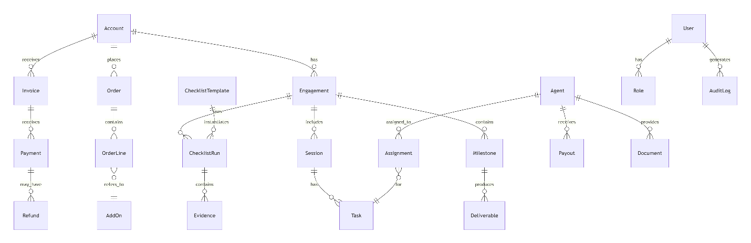
Core Entities with Sample JSON
Account (Customer):
json
{
"id": "acc_12345",
"name": "TechCorp Dubai",
"type": "business",
"address": {
"street": "Dubai Internet City",
"city": "Dubai",
"country": "UAE"
},
"contact": {
"primary_email": "ahmed@techcorp.ae",
"primary_phone": "+971501234567",
"language_preference": "ar"
},
"billing_currency": "AED",
"tax_id": "123456789012345",
"created_at": "2024-01-15T08:00:00Z",
"tenant_id": "tn_dubai_001"
}
Engagement with Plan:
json
{
"id": "eng_67890",
"account_id": "acc_12345",
"name": "Office Network Infrastructure",
"plan": {
"duration_weeks": 6,
"milestones": [
{
"sequence": 1,
"name": "Planning & Assessment",
"due_date": "2024-02-01",
"deliverables": ["Site survey report", "Network design"],
"budget_allocation": 0.2
},
{
"sequence": 2,
"name": "Infrastructure Installation",
"due_date": "2024-02-15",
"deliverables": ["Cabling complete", "Switches installed"],
"budget_allocation": 0.5
}
]
},
"status": "active",
"progress_percentage": 35
}
Checklist Run with Evidence:
json
{
"id": "clr_abc123",
"task_id": "task_456",
"agent_id": "agent_789",
"template_id": "template_net_install",
"items": [
{
"id": "item_1",
"description": "Verify switch installation",
"status": "completed",
"evidence": [
{
"type": "photo",
"url": "https://storage.blob.core.windows.net/evidence/switch1.jpg",
"timestamp": "2024-01-20T10:30:00Z",
"location": {
"lat": 25.2048,
"lng": 55.2708
},
"metadata": {
"device_id": "agent_mobile_001",
"pii_redacted": true
}
}
]
}
],
"started_at": "2024-01-20T09:00:00Z",
"completed_at": "2024-01-20T11:30:00Z",
"quality_score": 95
}
Row-Level Security Strategy
sql
-- Tenant isolation policy
CREATE SECURITY POLICY TenantFilter
ADD FILTER PREDICATE [dbo].fn_tenant_access_predicate(tenant_id) ON [dbo].[Accounts]
ADD BLOCK PREDICATE [dbo].fn_tenant_access_predicate(tenant_id) ON [dbo].[Accounts];

-- Function for tenant access control
CREATE FUNCTION fn_tenant_access_predicate(@tenant_id varchar(50))
RETURNS TABLE
WITH SCHEMABINDING
AS RETURN (
SELECT 1 AS access_result
WHERE @tenant_id = CAST(SESSION_CONTEXT(N'tenant_id') AS varchar(50))
OR IS_MEMBER('db_owner') = 1
);
7) Workflows
Onboarding & Assignment Flow
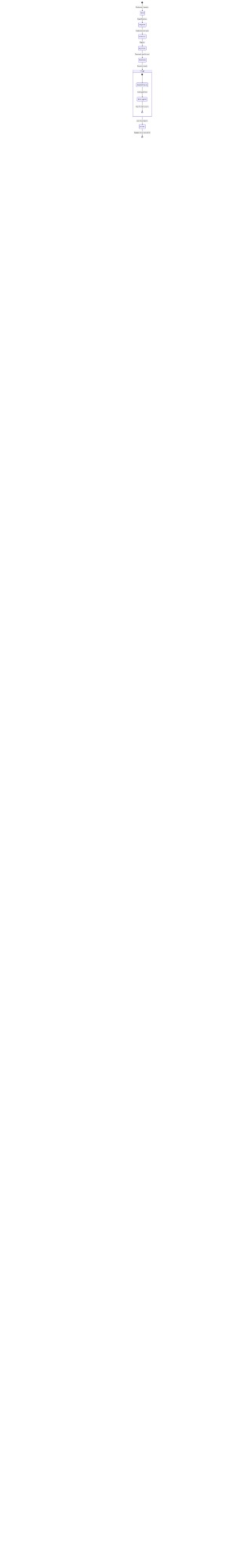
Field Task State Management
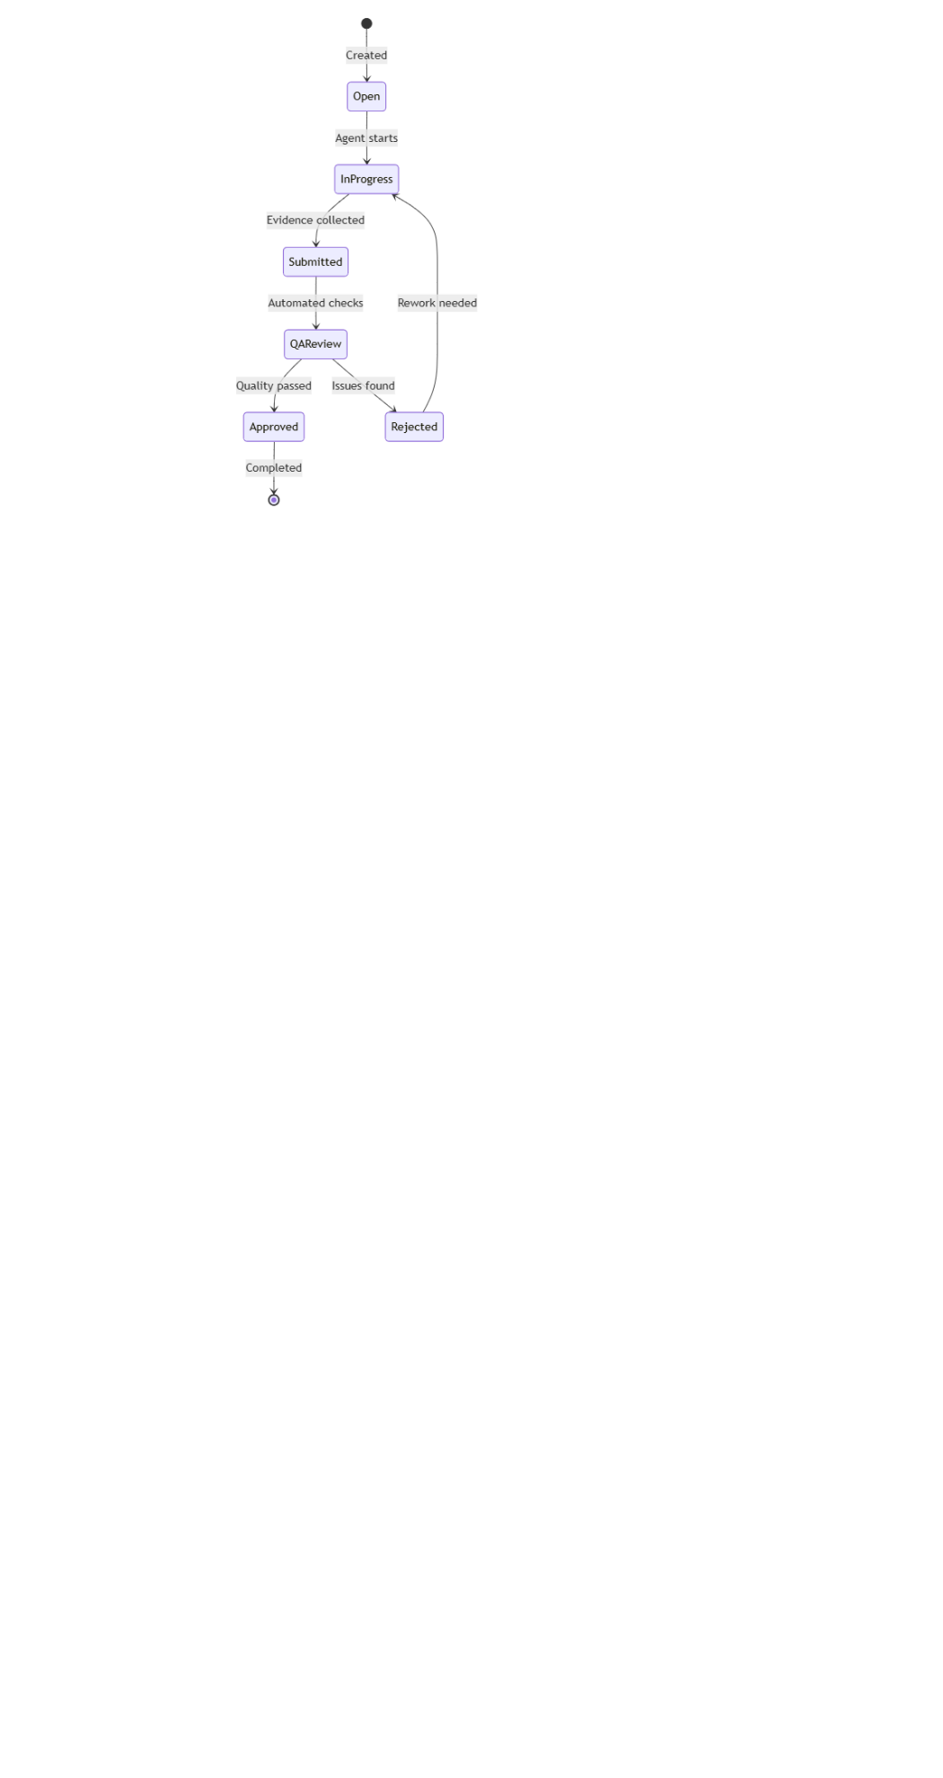
Billing & Payout Flow
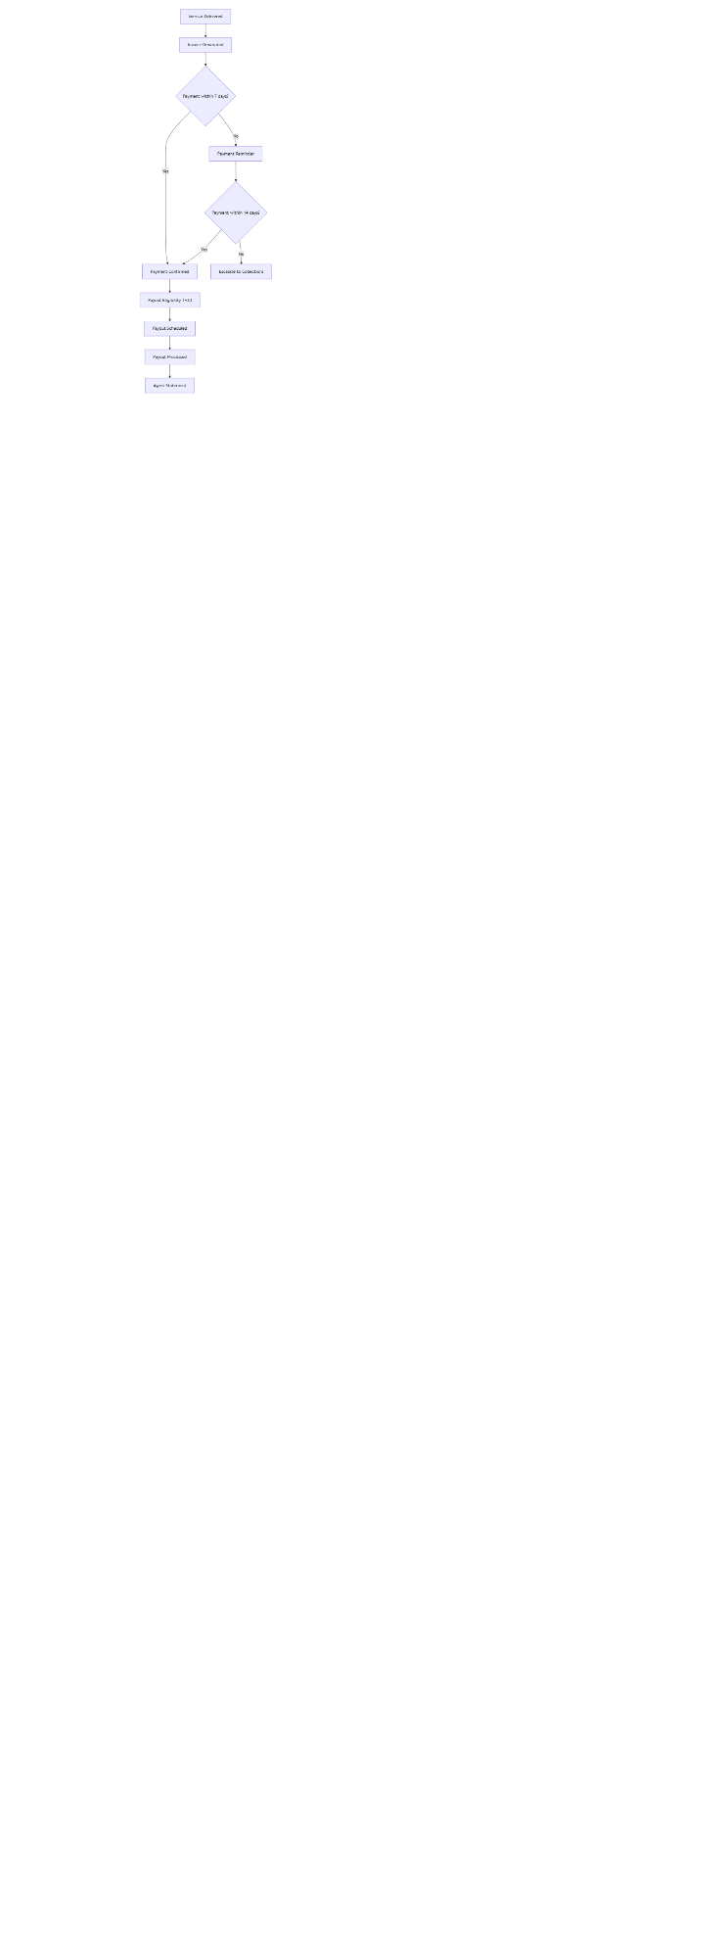
8) Technology Architecture
C4 Model Overview
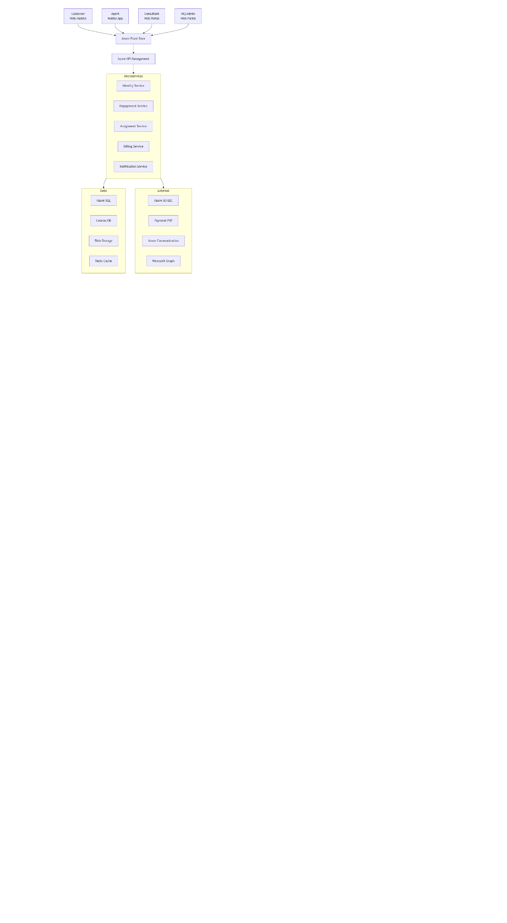
Context Diagram:
Container Diagram:
yaml
Frontend:
- Customer Web: React SPA
- Agent Mobile: React Native
- Admin Portal: React SPA

Backend Services (.NET 8):
- Identity Service: AuthN/AuthZ
- Engagement Service: Plans, milestones
- Field Service: Tasks, checklists, evidence
- Assignment Service: Agent matching
- Billing Service: Invoicing, payments
- Payout Service: Commission calculations
- Notification Service: Real-time comms

Data Stores:
- Azure SQL: Transactional data
- Cosmos DB: Events, messages
- Blob Storage: Documents, evidence
- Redis: Cache, sessions

Integration:
- Azure Service Bus: Event-driven architecture
- Azure SignalR: Real-time updates
- Azure Functions: Serverless processors
API Contracts
Engagement Status Endpoint:
yaml
/engagements/{id}/status:
get:
summary: Get engagement progress and next steps
parameters:
- name: id
in: path
required: true
schema:
type: string
responses:
200:
description: Engagement status
content:
application/json:
schema:
type: object
properties:
engagement_id:
type: string
current_milestone:
type: string
progress_percentage:
type: number
next_steps:
type: array
items:
type: object
properties:
action:
type: string
due_date:
type: string
assigned_to:
type: string
financial_status:
type: object
properties:
billed_amount:
type: number
paid_amount:
type: number
upcoming_invoices:
type: array
Evidence Submission Endpoint:
yaml
/tasks/{id}/evidence:
post:
summary: Submit task evidence
security:
- bearerAuth: []
requestBody:
required: true
content:
multipart/form-data:
schema:
type: object
properties:
photos:
type: array
items:
type: string
format: binary
notes:
type: string
location:
type: object
properties:
latitude:
type: number
longitude:
type: number
signature:
type: string
format: binary
responses:
202:
description: Evidence accepted for processing
400:
description: Validation failed - missing required evidence
Zero-Trust Security Architecture
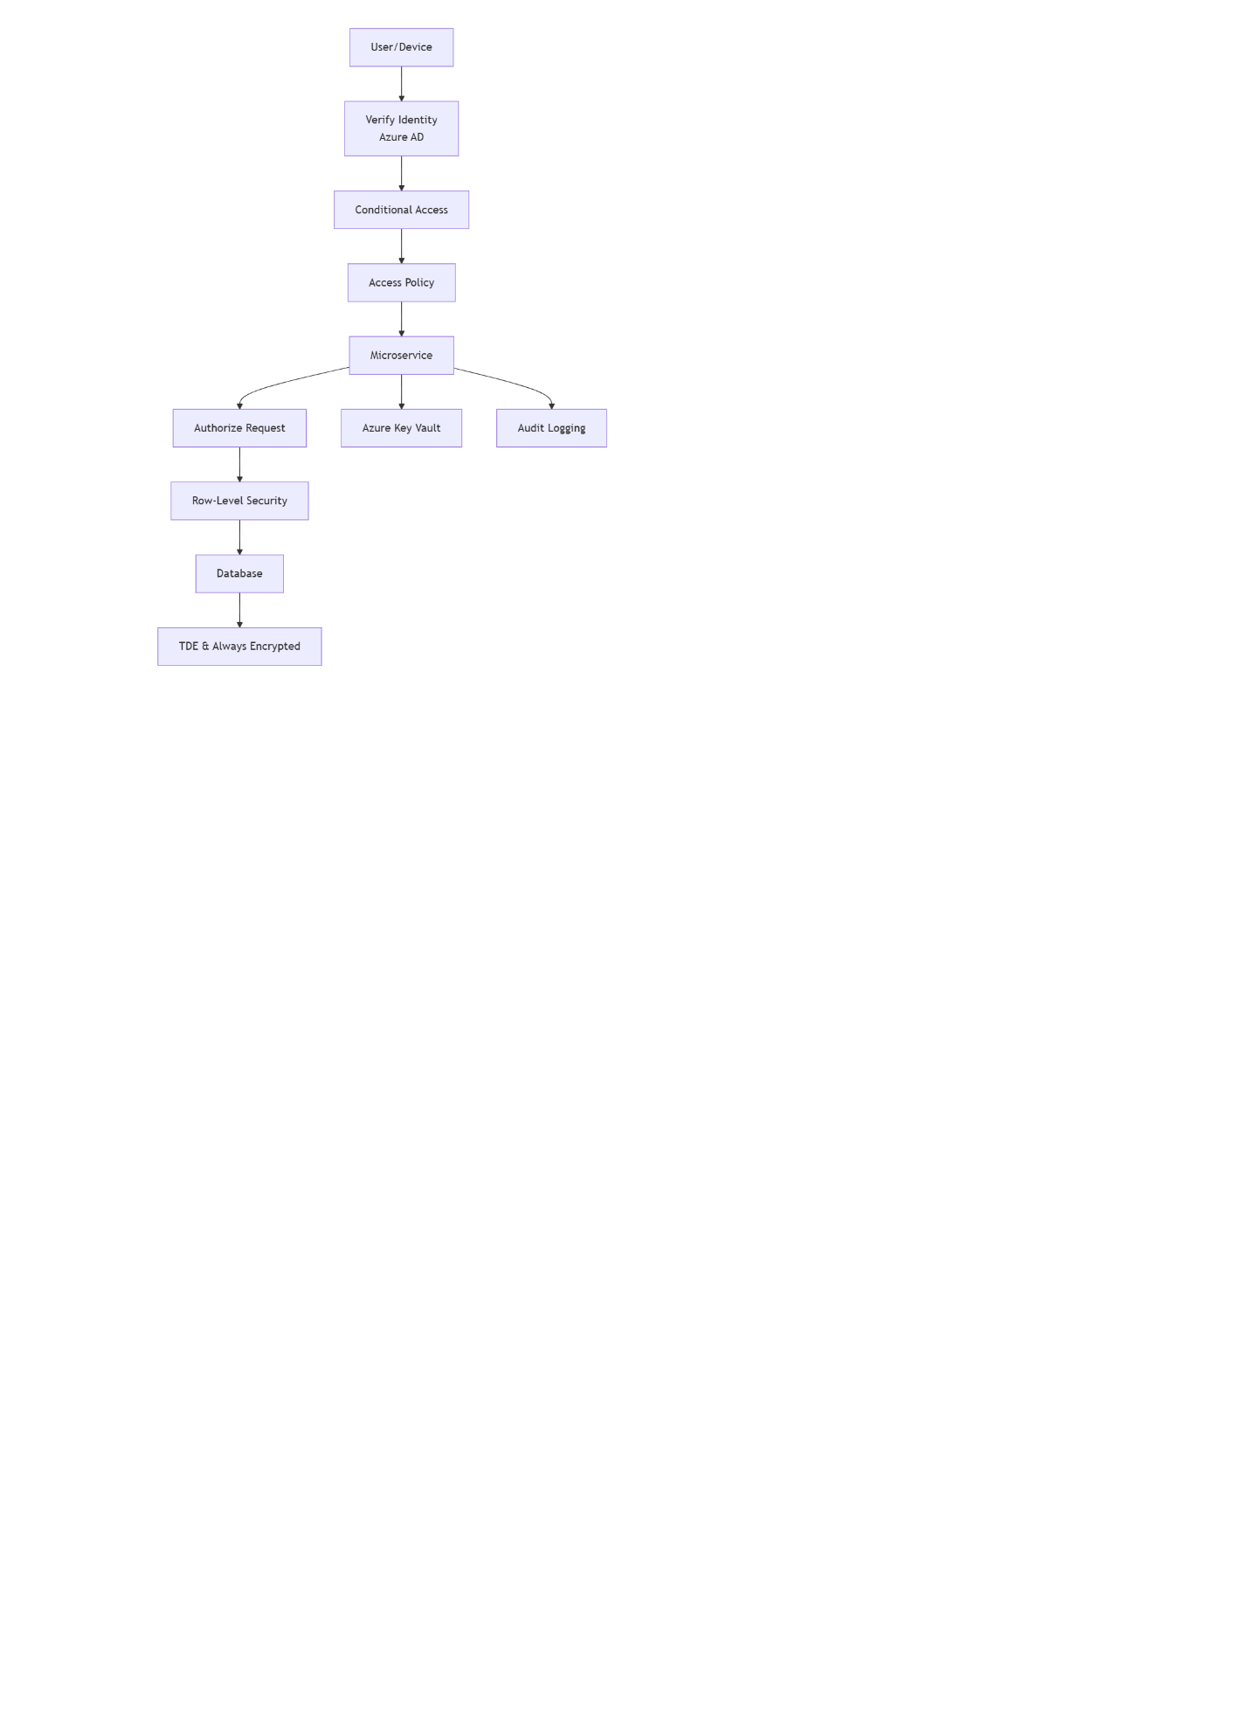
9) Security, Privacy, Compliance (UAE PDPL)
PDPL Compliance Framework
Data Protection Measures:
- Consent Management: Granular consent capture and tracking
- Purpose Limitation: Data usage strictly for service delivery
- Data Minimization: Collect only essential PII
- Subject Rights: Automated DSAR request handling
Technical Implementation:
csharp
// PII minimization in evidence storage
public class EvidenceProcessor
{
public async Task<EvidenceResult> ProcessMediaAsync(Stream media, string tenantId)
{
// Redact faces from photos
var redactedImage = await _computerVision.RedactFacesAsync(media);

// Strip metadata
var cleanImage = await _mediaTool.StripMetadataAsync(redactedImage);

// Encrypt with tenant-specific key
var encryptedResult = await _encryption.EncryptAsync(cleanImage, tenantId);

return new EvidenceResult {
ContentUrl = encryptedResult.Url,
PiiRedacted = true,
EncryptionKeyId = encryptedResult.KeyId
};
}
}
Mobile Security:
- Certificate pinning for API communication
- Biometric authentication for sensitive actions
- Remote wipe capability for compromised devices
- Jailbreak/root detection with automated logout
Backup & Disaster Recovery
- RPO: 15 minutes (transaction log backups)
- RTO: 4 hours for full service restoration
- Geo-redundant storage in UAE North & Central
- Quarterly DR drills with failover testing
10) Finance Engine
Commission & Payout Logic
csharp
public class PayoutCalculator
{
public PayoutCalculation CalculatePayout(Engagement engagement, Agent agent)
{
var baseAmount = engagement.ServiceFee;
var commissionRate = agent.CommissionTier?.Rate ?? 0.6; // 60% to agent

// Apply tier overrides
if (engagement.IsPremium)
commissionRate += 0.05; // 5% bonus for premium

var grossPayout = baseAmount * commissionRate;

// Adjust for refunds
var refundAdjustment = engagement.Refunds.Sum(r => r.Amount) * commissionRate;
var netPayout = grossPayout - refundAdjustment;

return new PayoutCalculation {
GrossAmount = grossPayout,
RefundAdjustments = refundAdjustment,
NetAmount = netPayout,
EligibleDate = engagement.CompletionDate?.AddDays(30),
Currency = engagement.Currency
};
}
}
VAT Compliance (UAE)
- 5% VAT applied to all taxable services
- Tax-inclusive pricing display
- VAT number validation for business customers
- Tax invoice generation with TRN numbers
11) KPIs & Dashboards
Key Performance Indicators
Sales Metrics:
- Lead-to-Win Rate: (Won Engagements / Qualified Leads) * 100
- Average Sales Cycle: SUM(Close Date - Create Date) / Won Count
- Add-on Attach Rate: (Engagements with Add-ons / Total Engagements) * 100
Delivery Excellence:
- On-time Milestone Rate: (On-time Milestones / Total Milestones) * 100
- First-Time-Right: (Tasks Approved First Time / Total Tasks) * 100
- Rework Rate: (Tasks Requiring Rework / Total Tasks) * 100
Customer Success:
- Time to First Value: First Deliverable Date - Engagement Start Date
- NPS: % Promoters - % Detractors
- Renewal Rate: (Renewed Engagements / Eligible Engagements) * 100
Power BI Dashboard Design
Executive Overview:
text
┌─────────────────────────────────────────────────────────┐
│ Monthly Performance Overview │
├─────────────────┬─────────────────┬─────────────────────┤
│ Revenue: AED 2.1M ▲12% │ Active Engagements: 45 │ NPS: 62 │
├─────────────────┼─────────────────┼─────────────────────┤
│ On-time Delivery: 94% │ FTR Rate: 96% │ CSAT: 4.8/5 │
└─────────────────┴─────────────────┴─────────────────────┘

📈 Revenue Trend (Last 6 Months)
📊 Service Line Performance
👥 Partner Quality Scores
12) Acceptance Criteria & DoD
Gherkin-style Examples
Assignment Engine:
gherkin
Feature: Intelligent Agent Assignment
Scenario: Assigning best-fit agents to tasks
Given an engagement requiring "network certification"
And available agents with varying certification levels
When the assignment engine runs
Then it should return top 3 agents ranked by match score
And each agent should have explainable selection reasons
And the consultant should be able to override the selection
And all assignment changes should be logged in AuditLog
Evidence Validation:
gherkin
Feature: Evidence Completeness Check
Scenario: Block submission with insufficient evidence
Given a stock count task requiring 3+ photos with geotags
When an agent attempts submission with only 2 photos
Then the system should block submission
And display error message in Arabic/English based on agent preference
And specify exactly what evidence is missing
And provide guidance on how to capture proper evidence
Definition of Done
- ✅ Code reviewed and approved
- ✅ Unit tests passing (>80% coverage)
- ✅ Integration tests validated
- ✅ Performance tested with load
- ✅ Security review completed
- ✅ UAE Arabic localization verified
- ✅ Documentation updated
- ✅ Deployed to staging environment
13) Delivery Plan
MVP Timeline (10 Weeks)
Sprint 0: Foundations (2 weeks)
- Azure environment setup
- Identity & access management
- Database schema deployment
- CI/CD pipeline establishment
Sprint 1: Core Entities & Plan Builder (3 weeks)
- Account, Engagement, Milestone entities
- Plan builder with 3/6/12 month templates
- Basic REST APIs
- React admin interface
Sprint 2: Customer App v1 (3 weeks)
- Customer dashboard with progress tracking
- Session management
- Payment integration (Checkout.com)
- Bi-lingual support (EN/AR)
Sprint 3: Agent App v1 (3 weeks)
- Mobile task management
- Checklist execution
- Evidence capture (photos, location)
- Offline capability
Sprint 4: Real-time & Add-ons (2 weeks)
- Live updates with SignalR
- Add-on marketplace
- Dynamic assignment engine
- Notification system
Sprint 5: Billing & Payouts (3 weeks)
- Invoicing with VAT
- Commission calculations
- Payout scheduling
- Financial reporting
Sprint 6: Security & Go-live (3 weeks)
- Security hardening
- Penetration testing
- App store submissions
- Production deployment
Post-MVP Roadmap
- WhatsApp Business integration
- Learning Management System (LMS) full
- Renewal automation engine
- Advanced analytics v2
- Dynamics 365 Field Service integration
14) Assumptions, Risks & Open Questions
Key Assumptions
- UAE market accepts 40% platform commission model
- Certified partner supply meets customer demand
- Payment service providers support required UAE payment methods
- Customers comfortable with digital evidence collection
Identified Risks
Risk | Impact | Probability | Mitigation
Partner shortage | High | Medium | Aggressive partner acquisition program
Payment failure rates | High | Low | Multiple PSP integration, manual fallback
Data residency compliance | High | Low | Azure UAE regions, legal review
Cultural adoption barriers | Medium | Medium | Localized UX, Arabic support
Open Questions for Resolution
- PSP Selection: Checkout.com vs Amazon Payment Services - final evaluation needed based on UAE market penetration and fee structures
- Video Communication: Microsoft Teams integration vs Azure Communication Services - decision pending cost analysis and feature requirements
- Offline Sync Strategy: Conflict resolution approach for complex field data - technical spike required
- UAE Regulatory: Final VAT treatment for platform services - ongoing legal consultation
Bi-lingual Implementation Notes
- Right-to-left layout support for Arabic
- Cultural adaptation of color schemes and imagery
- Local date/time formats (Hijri calendar optional)
- UAE-specific address formatting
- Legal compliance for Arabic contract templates

